**Gym Management System**

**Introduction / Background / Problem Statement**

Gyms today face challenges in efficiently managing memberships, tracking attendance, and supporting members’ health goals. Traditional manual systems are prone to errors, delays, and inefficiencies, leading to reduced member satisfaction. To address these limitations, this project proposes a Gym Management System that automates core processes such as member registration, membership management, attendance monitoring, and health tracking. The system also provides personalized healthcare tips, ensuring that members not only train but also maintain their overall well-being. By utilizing a web-based platform, the system aims to deliver scalability, accessibility, and a modern user experience.

**Idea Description**

The Gym Management System is a web-based platform designed to streamline gym operations while enhancing the member experience. Its key features include:

* **Member Registration & Profile Management**
* Collect and store details such as name, contact information, age, and gender.
* Allow members to update their profiles.
* **Membership Management**
* Support customizable membership plans (weekly, monthly, annual, etc.).
* Track membership status and send timely renewal reminders.
* **Attendance Tracking**
* Generate attendance reports for both members and management.
* Alert members about irregular attendance patterns.
* **Health Monitoring**
* Track BMI, calorie intake, and heart rate.
* Display progress through easy-to-understand charts and dashboards.
* **Healthcare Tips**
* Offer personalized health and fitness recommendations.
* Suggest diet and workout plans tailored to individual health data.

**Workflow of the Project**

* System Start:
* Users access the platform via the web interface (with potential for mobile expansion).
* Members log in to manage profiles, while administrators oversee gym operations.
* Member Registration & Profile:
* New members create accounts and fill in personal and emergency details.
* Members can update their profiles at any time.
* Membership Management:
* Administrators set up membership plans.
* Members receive automated renewal notifications before expiry.
* Attendance Tracking:
* Members check in via QR, RFID, or biometric validation.
* The system logs entries/exits and generates detailed reports.
* Health Monitoring:
* Members input or sync health metrics (e.g., BMI, calorie intake, heart rate).
* Progress is displayed visually with charts.
* Healthcare Tips:
* Personalized recommendations are generated based on health metrics.
* Tips range from dietary advice to workout suggestions.
* End of Cycle:
* Members can view attendance history, health progress, and membership status.
* Administrators can analyze reports to make data-driven decisions.

**Platform**

The Gym Management System will be built as a web-based application for scalability and accessibility. Development tools may include:

* Frontend: HTML, CSS, JavaScript (React/Angular)
* Backend: Node.js / Django / ASP.NET
* Database: MySQL or PostgreSQL
* Future expansion includes a mobile app (Android/iOS) for on-the-go access.

**Project Timeline**

* Week 1-2: Requirement Analysis
* Collect input from gym staff and members.
* Week 3-6: System Design
* Develop wireframes, database schema, and UI/UX design.
* Week 7-12: Development
* Build and test modules iteratively (registration, membership, attendance, health tracking).
* Week 13-15: Testing & Deployment
* Conduct functional and user testing.
* Deploy system for live usage.
* Train staff and provide maintenance updates.

**Target Population**

* Gym Owners and Administrators – for efficient management.
* Gym Members – for personalized training and progress tracking.
* Trainers – for monitoring member performance and attendance.
* Health-Conscious Individuals – seeking a structured fitness experience.

**Social and Economical Values / Benefits**

* Social Value:
* Promotes fitness and health awareness.
* Provides personalized wellness support.
* Encourages consistency through attendance tracking.
* Economic Value:
* Reduces manual administrative costs.
* Boosts revenue via timely renewals and improved retention.
* Potential for monetization through premium plans or fitness consulting.

**Conclusion**

The Gym Management System is designed to automate and optimize gym operations, ensuring efficiency, accessibility, and enhanced member satisfaction. By combining operational management with health-focused features, it positions itself as more than a management tool — it becomes a fitness companion for members.

* **Limitations**
* Health data depends on manual input unless integrated with wearables.
* Initial release focuses on web; mobile app will be introduced later.
* **Future Works**
* Integration with fitness wearables (e.g., smartwatches, fitness bands).
* Mobile app for real-time access.

**Summary**

The Gym Management System enhances gym efficiency by automating routine tasks and personalizing the member experience. With features such as attendance tracking, health monitoring, and tailored healthcare tips, the system benefits both gym owners and members. Future enhancements like mobile apps, wearables, and AI support will expand its usability and appeal.

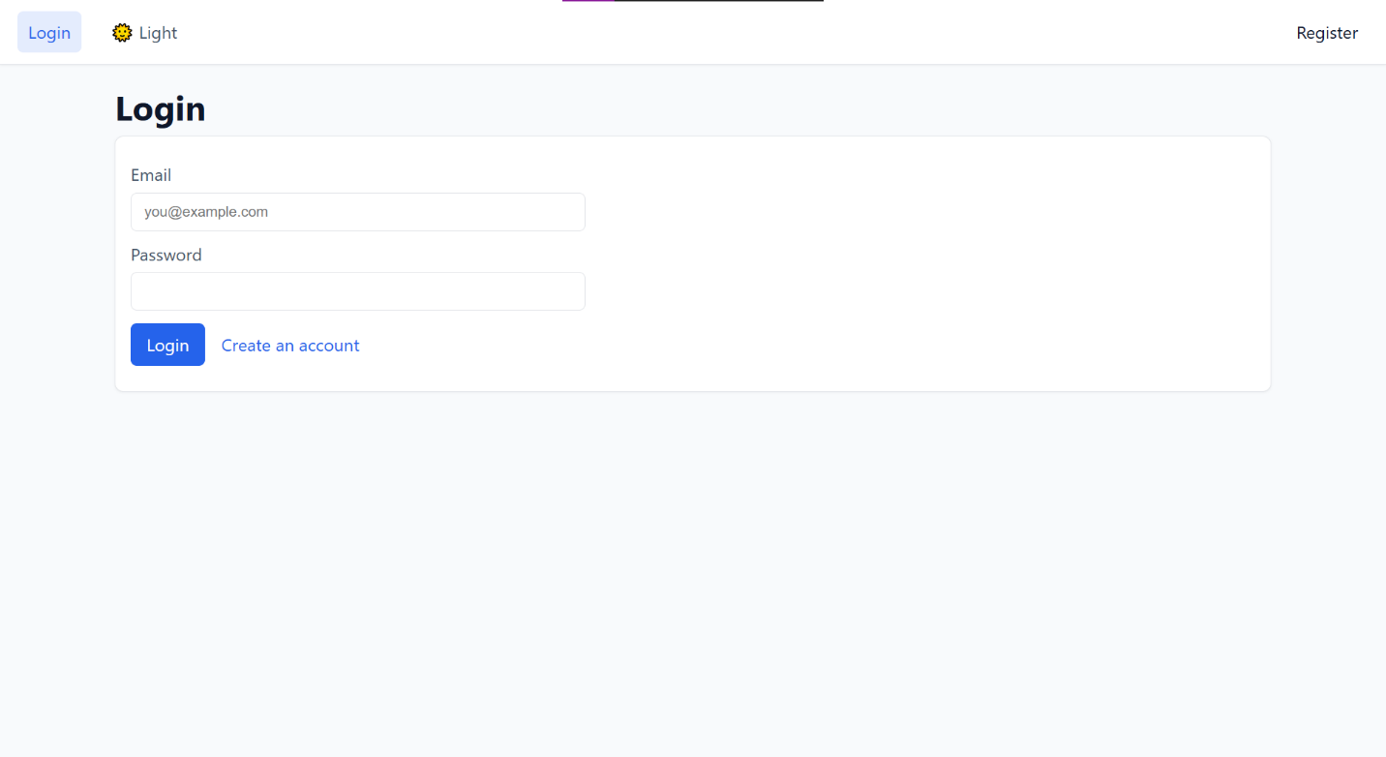**Project Screenshots**

